**DECENTRALIZED MEDICINE SUPPLY CHAIN MANAGEMENT AND ELIMINATE COUNTERFEIT MEDICINE USING BLOCKCHAIN**

##### A PROJECT REPORT

###### ***Submitted by***

**SATHISH KUMAR T P** **211418104235**

**SUNDARESAN R 211418104273**

**VISHAL S 211418104312**

***in partial fulfillment for the award of the degree***

***of***

**BACHELOR OF ENGINEERING**

##### In

##### COMPUTER SCIENCE AND ENGINEERING



**PANIMALAR ENGINEERING COLLEGE.**

(An Autonomous Institution, Affiliated to Anna University, Chennai)

**MAY 2022**

**PANIMALAR ENGINEERING COLLEGE.**

(An Autonomous Institution, Affiliated to Anna University, Chennai)

**BONAFIDE CERTIFICATE**

Certified that this project report **“****DECENTRALIZED MEDICINE SUPPLY CHAIN MANAGEMENT AND ELIMINATE COUNTERFEIT MEDICINE USING BLOCKCHAIN”** is the bonafide work of “**SATHISH KUMAR T P (211418104235), SUNDARESAN R (211418104273), VISHAL S (211418104312)”** who carried out the project work under my supervision.

**SIGNATURE SIGNATURE**

**Dr.S.MURUGAVALLI,M.E.,Ph.D., Mr.C.THYAGARAJAN, M.E,(Ph.D),**

**HEAD OF THE DEPARTMENT ASSISTANT PROFESSOR**

DEPARTMENT OF CSE, DEPARTMENT OF CSE,

PANIMALAR ENGINEERING COLLEGE, PANIMALAR ENGINEERING COLLEGE,

NAZARETHPETTAI, NAZARETHPETTAI,

POONAMALLEE, POONAMALLEE,

CHENNAI-600 123. CHENNAI-600 123.

Certified that the above candidate(s) was/ were examined in the Anna University Project Viva-Voice Examination held on...........................

**INTERNAL EXAMINER EXTERNAL EXAMINER**

**DECLARATION BY THE STUDENT**

We **SATHISH KUMAR T P (211418104235), SUNDARESAN R (211418104273) & VISHAL S (211418104312)** hereby declare that this project report titled **DECENTRALIZED MEDICINE SUPPLY CHAIN MANAGEMENT AND ELIMINATE COUNTERFEIT MEDICINE USING BLOCKCHAIN**, under the guidance of **Mr.C.THYAGARAJAN** is the original work done by us and we have not plagiarized or submitted to any other degree in any university by us.

**ACKNOWLEDGEMENT**

We would like to express our deep gratitude to our respected Secretary and Correspondent **Dr.P.CHINNADURAI, M.A., Ph.D.,** for his kind words and enthusiastic motivation, which inspired us a lot in completing this project.

We express our sincere thanks to our Directors **Tmt.C.VIJAYARAJESWARI**, **Dr.C.SAKTHI KUMAR,M.E,Ph.D** and **Dr.SARANYASREE SAKTHI KUMAR ,B.E.,MBA.,Ph.D.,**for providing us with the necessary facilities for completion of this project.

We also express our gratitude to our Principal **Dr.K.MANI ,M.E.,Ph.D.,**for his timely concern and encouragement provided to us throughout the course.

We thank the Head of the CSE Department, **Dr. S. MURUGAVALLI, M.E., Ph.D.,** for the support extended throughout the project.

We would like to thank my **Project Coordinator** **DR.N.PUGAZHENDI M.E.,Ph.D.** and **Project Guide Mr.C.THYAGARAJAN M.E.,(Ph.D.).,** all the faculty members of the Department of CSE for their advice and suggestions for the successful completion of the project.

Lastly we take the opportunity to thank all our staff members of the department of computer science and engineering. Regards to our family and friends who offered an unflinching moral support for the completion of this project.

**SATHISH KUMAR T P**

**SUNDARESAN R**

**VISHAL S**

**ABSTRACT**

In this paper, we review existing literature and applications available for the supply chain system. Besides, this work also proposes workflows involved in the medicine supply chain management using blockchain technology for better data management. Counterfeit drugs are one of the consequences in existing supply chains which not only has serious impact on human health but also causes severe economic loss to the medical industry. The illicit drug market contributes significantly to the production of counterfeit drugs as its additives and add contaminated, improperly stored, and counterfeit ingredients. This includes accessing and managing a large amount of medical data stored in blockchain. To overcome, we use Blockchain technology to provide a secure and reliable platform for secure data sharing in application areas such as the supply chain management, financial sector, food industry, internet of things, energy sector and healthcare.

**TABLE OF CONTENTS**

|  |  |  |
| --- | --- | --- |
| **CHAPTER NO.** | **TITLE** | **PAGE NO.** |
|
|  | **ABSTRACT** | I |
|  | **LIST OF FIGURES** | IV |
|  | **LIST OF TABLES** | VI |
| **1** | **INTRODUTION** | 1 |
| **2** | **LITERATURE SURVEY** | 3 |
| **3** | **SYSTEM ANALYSIS** | 8 |
|  | 3.1 EXISTING SYSTEM | 9 |
|  | 3.2 PROPOSED SYSTEM | 10 |
|  | 3.3 FEASIBILITY STUDY | 11 |
|  | 3.3.1 INTRODUCTION | 11 |
|  | 3.3.2 FINANCIAL FEASIBILITY | 11 |
|  | 3.3.3 TECHNICAL FEASIBILITY | 12 |
|  | 3.3.4 RESOURCE FEASIBILITY | 12 |
|  | 3.4 HARDWARE REQUIREMENTS | 13 |
|  | 3.4.1 QR CODE READER | 13 |
|  | 3.4.2 LAPTOP/DESKTOP | 13 |
|  | 3.5 SOFTWARE REQUIREMENTS | 14 |
|  | 3.5.1 VISUAL STUDIO CODE | 14 |
|  | 3.5.2 FIREBASE | 14 |
|  | 3.5.3 TRUFFLE | 15 |
|  | 3.5.4 GANACHE | 15 |
|  | 3.5.5 JAVASCRIPT | 16 |
|  | 3.5.6 METAMASK | 16 |
| **4** | **SYSTEM DESIGN** | 17 |
|  | 4.1 E-R DIAGRAM | 18 |
|  | 4.2 DFD DIAGRAM | 20 |
|  | 4.2.1 LEVEL 0 DFD | 20 |
|  | 4.2.2 LEVEL 1 DFD | 21 |
|  | 4.2.3 LEVEL 2 DFD | 22 |
|  | 4.3 UML DIAGRAM | 23 |
|  | 4.3.1 USECASE DIAGRAM | 24 |
|  | 4.3.2 ACTIVITY DIAGRAM | 26 |
|  | 4.3.3 CLASS DIAGRAM | 27 |
|  | 4.3.4 COMPONENT DIAGRAM | 29 |
|  | 4.3.5 SEQUENCE DIAGRAM | 30 |
|  | 4.3.6 DATA DICTIONARY | 31 |
| **5** | **SYSTEM ARCHITECTURE AND MODEL REPRESENTATION** | 33 |
|  | 5.1 SYSTEM FRAMEWORK | 34 |
|  | 5.2 MODULE DESIGN SPECIFICATION | 35 |
|  | 5.2.1 MODEL REPRESENTATION OF MEDBLOC | 35 |
|  | 5.2.2 USER DETAILS REGISTRATION | 36 |
|  | 5.2.3 USER ACCOUNT CREATION | 37 |
|  | 5.2.4 ADD MEDICINE DETAILS | 37 |
|  | 5.2.5 VERIFY MEDICINE DETAILS | 38 |
|  | 5.2.6 CHECK MEDICINE DETAILS | 39 |
| **6** | **SYSTEM IMPLICATIONS** | 40 |
|  | 6.1 WORKING PRINCIPLE OF MEDICINE SUPPLY CHAIN MANAGEMENT | 41 |
| **7** | **TESTING** | 43 |
|  | 7.1 TESTING OBJECTIVES | 44 |
|  | 7.2 TYPES OF TESTS | 44 |
|  | 7.2.1 UNIT TESTING | 44 |
|  | 7.2.2 INTEGRATION TESTING | 44 |
|  | 7.2.3 FUNCTIONAL TESTING | 45 |
|  | 7.2.4 SYSTEM TESTING | 45 |
|  | 7.2.5 ACCEPTANCE TESTING | 45 |
|  | 7.3 TESTCASES AND RESULTS | 46 |
| **8** | **CONCLUSION AND FUTURE ENHANCEMENT** | 48 |
|  | 8.1 CONCLUSION | 48 |
|  | 8.2 FUTURE ENHANCEMENT | 48 |
| **9** | **APPENDICES** | 49 |
|  | 9.1 CODING | 50 |
|  | 9.2 SCREEN SHOTS | 58 |
| **10** | **BIBLIOGRAPHY** | 63 |

**LIST OF FIGURES**

|  |  |  |
| --- | --- | --- |
| **FIGURE NO** | **FIGURE NAME** | **PAGE NO** |
|
| **FIG.3.1** | QR CODE READER | 13 |
| **FIG.3.2** | DEVICES TO DISPLAY MEDBLOC | 13 |
| **FIG.3.3** | VISUAL STUDIO CODE | 14 |
| **FIG.3.4** | FIREBASE | 14 |
| **FIG.3.5** | TRUFFLE | 15 |
| **FIG.3.6** | GANACHE | 15 |
| **FIG.3.7** | JAVASCRIPT | 16 |
| **FIG.3.8** | METAMASK | 16 |
| **FIG.4.1** | ENTITY-RELATIONSHIP DIAGRAM | 18 |
| **FIG.4.2.1** | LEVEL 0 DFD | 20 |
| **FIG.4.2.2** | LEVEL 1 DFD | 21 |
| **FIG.4.2.3** | LEVEL 2 DFD | 22 |
| **FIG.4.3.1** | USECASE DIAGRAM | 24 |
| **FIG.4.3.2** | ACTIVITY DIAGRAM | 26 |
| **FIG4.3.3** | CLASS DIAGRAM | 27 |
| **FIG.4.3.4** | COMPONENT DIAGRAM | 29 |
| **FIG.4.3.5** | SEQUENCE DIAGRAM | 30 |
| **FIG.5.1** | SYSTEM ARCHITECTURE | 34 |
| **FIG.5.2.2** | USER DETAILS REGISTRATION | 36 |
| **FIG.5.2.3** | USER ACCOUNT CREATION | 36 |
| **FIG.5.2.4** | ADD MEDICINE DETAILS | 37 |
| **FIG.5.2.5** | VERIFY MEDICINE DETAILS | 38 |
| **FIG.5.2.6** | CHECK MEDICINE DETAILS | 39 |
| **FIG.6.1** | WORKING OF MEDICINE SUPPLY CHAIN MANAGEMENT SYSTEM | 41 |
| **FIG.6.2** | WORKING OF MEDICINE SUPPLY CHAIN MANAGEMENT SYSTEM | 42 |
| **FIG.A.1** | SCREENSHOTOF WELCOME PAGE(MEDBLOC) | 58 |
| **FIG.A.2** | SCREENSHOT OF USER SELECTION PAGE | 58 |
| **FIG.A.3** | SCREENSHOT OF ACCOUNT LOGIN PAGE | 59 |
| **FIG.A.4** | SCREENSHOT OF MANUFACTURER ENTERED MEDICINE DETAILS | 59 |
| **FIG.A.5** | SCREENSHOT OF ENTERING MEDICINE DETAILS PAGE | 60 |
| **FIG.A.6** | SCREENSHOT OF SUPPLIER PAGE BEFORE VERIFY MEDICINE | 60 |
| **FIG.A.7** | SCREENSHOT OF SUPPLIER PAGE AFTER VERIFICATION | 61 |
| **FIG.A.8** | SCREENSHOT OF CONSUMER PAGE TO CHECK A MEDICINE | 61 |
| **FIG.A.9** | SCREENSHOT OF MEDICINE DETAILS ENTERED IN BLOCKCHAIN | 62 |

**LIST OF TABLES**

|  |  |  |
| --- | --- | --- |
| **TABLE NO** | **TABLE NAME** | **PAGE NO** |
| 4.1 | E-R DIAGRAM SYMBOL DESCRIPTION | 19 |
| 4.3.1 | USE CASE DIAGRAM SYMBOL DESCRIPTION | 23 |
| 4.3.2 | ACTIVITY DIAGRAM SYMBOL DESCRIPTION | 25 |
| 4.3.3 | COMPONENT DIAGRAM SYMBOL DESCRIPTION | 29 |
| 4.3.6 | DATA DICTIONARY DESCRIPTION | 31 |
| 7.3 | TEST CASES AND POSSIBLE RESULTS | 46 |

**INTRODUCTION**

1. **INTRODUCTION**

The main issues in the counterfeit medicine supply chain, are how the drugs are manufactured in medical industry. The traceability of pharmaceutical ingredients during manufacture is tedious process, so intaking counterfeit drugs can ultimately affect to consumer patient health or even death. With Blockchain technology, we can capable of providing a complete traceability of drugs, from manufacturer to end consumer, and the ability to identify counterfeit-drugs.

The Illegal medicine supplies causes the serious threat to the society. The counterfeited medicines make a serious effect on the health of the people and also cause revenue loss to the legitimate medicine manufacturing organizations. Blockchain solutions for healthcare, government sector, supply chain and logistics have recently gained huge amount of acceptance as they provide an immutable and transparent way to record transactions between non-trusting stakeholders. A Medicine supply chain follows an end-to-end process from collecting the active medicine ingredients to manufacturing the final medicine product distributed and delivered to the end-users.

We can use Blockchain technology for creating a private permissioned network to trace and track events in the medicine supply chain. This process minimizes the interruptions in the drug supply chain, increase collaboration between untrusted stakeholders and creates an immutable decentralized drug safety and traceability system.

**LITERATURE SURVEY**

1. **LITERATURE SURVEY**

**U. Padmavathi and N. Rajagopalan [1],2021** Medical devices are subjected to strict certification processes that vary depending on each country’s healthcare regulations and approvals. This adds to the hurdles in terms of required urgent supply and delivery of medical devices and supplies. The extensive and lengthy testing procedures and the long distances that threaten traceability, fast response, security, and trust can be achieved through blockchain-based decentralized digital manufacturing. The concept of blockchain technology has been introduced in 2008.Blockchain offers distinctive features, such as decentralization, audit, immutability, traceability, security, and trust. It is governed by a group of computer nodes named clusters that work together on verifying and executing transactions. The technology uses cryptography (hashes) and digital signatures, for which two keys are utilized, public and private—generated from the Ethereum address and mining following the consensus mechanism

**Ekblaw, A.; Azaria, A.; Halamka, J.D.; Lippman, A [2], 2016** Blockchain is the one of the most revolutionized technologies of the future. It uses distributed ledger technology to record and transmit transparent, secure, controllable, and fault-tolerant data. Blockchain has the capability to make organizations decentralized, transparent, efficient, democratic and secure. Over the years, many blockchain platforms have been proposed in the literature. These blockchain applications could be segregated into three categories, i.e., Public Blockchain, Private Blockchain, and Consortium Blockchain. The MedRec is a bitcoin-based solution that aims to resolve issues like system interoperability, slow access to medical data, patient, agency, fragmentation, etc. The novel blockchain-based solution provides patients with complete access to medical information and immutable logs across providers.

**Francisco K and Swanson D [3],2018** The global counterfeit drug trade impacts all pharmaceutical stakeholders including hospitals, pharmacies, wholesale distributors, global health programs, and regulatory authorities. The Illegal drug market contributes immensely toward producing fake and fraudulent medicines as its actors add contaminated, improperly stored, and falsified ingredients. Blockchain technology enables creating a private permissioned network to trace and track events in the pharmaceutical supply chain and provides time stamped records of each transaction performed. Examples of events includes, execution and owner, time, location of transaction, and which stakeholders were involved

**Lemieux, V.L [4**] **,2016**Legacy systems typically only share healthcare resources internally in the medical and healthcare field and are not fully compatible with external systems. Nonetheless, evidence indicates numerous benefits from integrating these networks for interconnected and better healthcare, calling for interconnection between different organizations for health informatics researchers. One of the most critical issues is multi-organizational data exchange, which demands that medical data obtained by a healthcare provider be easily available to other organizations, such as a physician or research institute. In many healthcare implementations, blockchain technology redefines data processing and governance. This is to its adaptability and unprecedented segmentation, secure and sharing of medical data and services. In the healthcare industry, blockchain technology is at the forefront of many current developments.

**Kumar, T.; Ramani, V.; Ahmad, I.; Braeken, A; Harjula, E; Ylianttila [5],2018** blockchain and smart contracts how blockchain based smart contracts has the potential to address different healthcare issues. In their work they took some initial steps to adopt blockchain technology for different healthcare use cases and pointed towards different challenges in the implementation of blockchain technology. They have elaborated that developing blockchain based apps can address healthcare issues in more efficient ways, security and privacy aspects of data and personal information handling underlining all of the blockchain technology implementations. It is the value of the secure processing of data–in the sense that it cannot be manipulated. Access to personal data has become a concern in this era of digital world, with challenging aspects of security and privacy. Digital security is a major challenge due to hacking motives and violations of privacy. This is possible in the eHealth area where patient’s health information management system must comply with many legislations while remaining accessible to healthcare professionals who are duly authorized.

**Medicalchain Whitepaper 2.1. Tech. Rep. Medicalchain[6], 2018**MedicalChain solved these problems by putting medical record transactions on the blockchain to create a smart healthcare ecosystem. In MedicalChain, a smart contract is launched to give time-limited access to a patient’s electronic health record. Doctors write notes and scan lab results, which are all recorded as transactions. The pharmacy dispenses medication and also records the transaction on the blockchain. The patient gives time-limited access to their insurer for verification of treatment and payment settlement. The patient gives time-limited access to their insurer for verification of treatment and payment settlement. With smart contracts, patients allow doctors to remotely review medical cases and provide advice or a second opinion. Patients given access to their health record to insurers to monitor fitness progress and be rewarded with tokens or reduced insurance premiums. Patients are also rewarded for giving research institutions time-limited access to their health record for medical trial purposes. MedicalChain issues Med Tokens, which patients use for storing electronic health records on the blockchain, data from wearable fitness devices, and transfer value and payments. MedicalChain will also be a platform that enables developers to build smart applications that analyze all of these data and provide recommendations, such as nutrition and fitness routines.

**Schlegel, M.; Zavolokina, L.; Schwabe, G.[7],2018** . New projects can raise capital by issuing tokens and be exchanged for products, services, or cash. Several blockchain-based startups like Starbase raised millions of dollars through such token sales. Today, due to lack of transparency and mistakes in public records, buying and selling real estate is difficult. In the real-estate industry, blockchain technology is also used to keep records secure, transparent, and to speed up the buying and selling process. The decentralized distributed ledger ensures the accuracy of a document, tracking, verifying ownership, and transferring property deeds. Ubitquity is a secure platform based on blockchain technology for real-estate records-keeping that is a substitute of a legacy-based system.

**SYSTEM ANALYSIS**

**3.SYSTEM ANALYSIS**

**3.1 EXISTING SYSTEM:**

***1.Visibility:***

A lack of visibility into the pharmaceutical supply chain may be the reason of many challenges faced by the medical industry like Drug shortages & Counterfeits.

***2. Logistics coordination:***

Medicine supply chain has various issues in processes or systems. A single drug or treatment may be administered to thousands of hospitals through distributors. It can be difficult to keep track of logs or meet each buyer’s requirements.

***3. Compliance:***

Poor compliance can cost millions in penalties, sometimes it leads to imprisonment for supply chain leaders, and increase the thread to consumers(end-users).

● Poor coordination between suppliers and supply chain management.

● Lack of visibility in Shipment.

● Selling of expired medicines.

● Prevention of shortages

***4.Cold-chain shipping:***

A cold chain is a temperature-controlled supply chain. It typically involves constant refrigeration of the medical product from the time of its production through its transportation, handling, storage, and delivery.

**3.2 PROPOSED SYSTEM:**

The purpose of the new system is to implement the features of blockchain technology and add traceability, and security to the medicine supply chain, and to provide visibility to manufacturers and medicine regulatory authority of the Supply Chain Management system.

***1. To Increase Trust and Transparency:***

The manufacturer and customers being able to track pharmaceutical products throughout the supply chain, so that they will trust each other.

***2. Traceability:***

Once the manufacturer produces a medicine, he will register it on the Ethereum blockchain, and here after the medicines will be tracked and authenticated at each stage of their journey. As the drugs ownership changes physically, its ownership will be transferred simultaneously on the blockchain network by entering data to it. Consumer will be able to track of their medicine after they bought from pharmacy.

***3. Add Visibility and Protect Privacy:***

Blockchain is the technology that can guaranty to verify the originality of a piece of data that is made available publicly while keeping the private data of an entity secrete and without any compromise on privacy.

***4. Extended Security:***

Blockchain is the most secured ledger systems because each piece of data in blockchain is been encrypted. Blockchain uses immutable type of database and the information once it is stored, it cannot be modified or deleted.

***5. Database for Future Statistics:***

Using Regular databases for storing record of medicine/patient data was not secure and privacy was at risk, but using blockchain technology, medicine data can be stored without sharing his private record.

**3.3 FEASIBILITY STUDY:**

**3.3.1 Introduction:**

A Feasibility Study includes a nitty gritty evaluation of the need value and common sense of a proposed enterprise, such as framework development. The procedure of outlining and executing record-keeping frameworks has adequate responsibility and asset suggestions for an association. Possibility study will enable you to settle on educate and straightforward choice at urgent focuses during the developmental procedure to decide if it is operationally, economically and in fact reasonable to deliver with a specific strategy.

**3.3.2 Financial Feasibility: -**

All programmable calculations in Ethereum blockchain cost some fees to avoid the abuse of network and to overcome computational issues. The fee in Ethereum blockchain is specified as gas to run all sort of transactions. Gas refers to the payment or price value required for a successful transaction or execution of a contract on the Ethereum blockchain platform. The exact price of gas is determined by the network miners to process a transaction met by the gas price. Hence all the operations, computations, message call, creation/deployment of smart contracts and storage on Ethereum virtual machine (EVM) needs gas to perform all these tasks. If someone wants to do any sort of operation on EVM, they must have specific amount of gas in their account to execute transactions on Ethereum virtual machine. There is a gas limit for every transaction, so if there is any unused gas it will return to the user account after the execution of transactions, since the process is automated.

From these it’s clear that this project is financially feasible.

**3.3.3 Technical feasibility:**

This project is a web-based application. The main technologies that are associated with project are:

* + Blockchain - Ethereum
  + Language -Solidity
  + Database - Firebase
  + JavaScript and libraries are used in Front end.
  + Tools-Ganache, Lite-Server, Visual studio, Truffle, Meta mask

Each of the technologies are freely available and the technical skills required are manageable. Time limitations of the product and the ease of implementing using these technologies are synchronized.

A blockchain network is a distributed ledger where all pharmaceutical supply chain stakeholders store their core business data. One of the greatest advantages and selling points of blockchain technology is its resilience against various types of attacks, including cyberattacks. The role of drug regulatory authorities includes quality checks and monitor the quality, safety, and efficacy and post market surveillance of pharmaceutical products. From this it is clear that our project is technically feasible.

**3.3.4 Resource Feasibility:**

Resources that are required for our project are:

* Programming Device
* Hosting Space
* Programming Tools
* Programming Individual.

So it’s clear that project has required resource feasibility.

**3.4 HARDWARE ENVIRONMENT**

**3.4.1 QR CODE READER:**

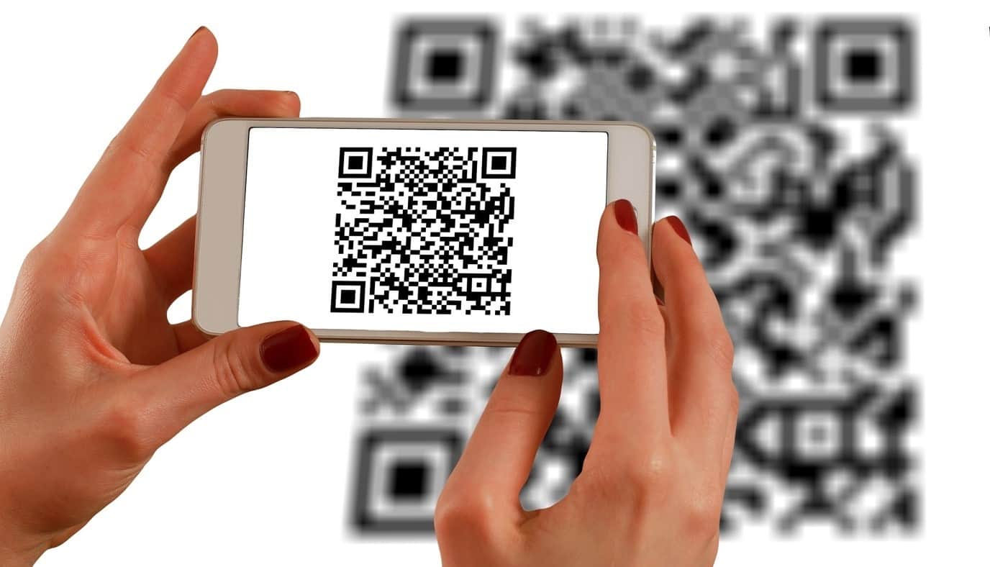A QR -code a type of barcode that can be read easily by a digital device and which stores information as a series of pixels in a square-shaped grid. It can be scanned using a QR scanner or a smartphone with built-in camera.

***FIG.3.1* QR CODE READER**

**3.4.2 LAPTOP/DESKTOP:**

Laptops or Desktop is used to view the MEBLOC application in the browser with internet access. Laptop is used as a platform to run the web Application for the Medicine Supply Chain Management System.



***FIG.3.2* DEVICES TO DISPLAY MEDBLOC**

**3.5 SOFTWARE ENVIRONMENT**

**3.5.1 VISUAL STUDIO CODE:**

Visual Studio Code is a code editor redefined and optimized for building and debugging modern web and cloud applications.  is a source-code editor that can be used with a variety of programming languages, including Java, JavaScript, Go, Node.js, Python, C++. It allows users to open one or more directories, which can then be saved in workspaces for future reuse.

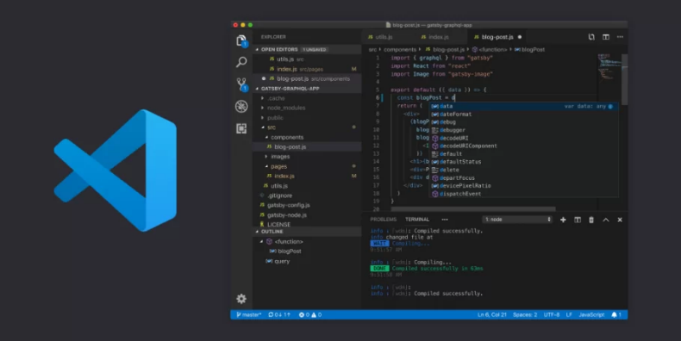

***FIG.3.3* VISUAL STUDIO CODE**

**3.5.2 FIREBASE:**

Google Firebase is a Google-backed application development software that enables developers to develop iOS, Android and Web apps. Firebase provides tools for tracking analytics, reporting and fixing app crashes, creating marketing and product experiment.

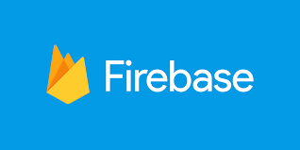

***FIG.3.4* FIREBASE**

**3.5.3 TRUFFLE:**

Truffle is a development environment, testing framework and asset pipeline for Ethereum, aiming to make Ethereum development easier. Built-in smart contract compilation, linking, deployment and binary management. Write automated tests for your contracts in both JavaScript and Solidity, Truffle takes care of managing your contract artifacts so you don't have to. Includes support for custom deployments, library linking and complex Ethereum applications.



***FIG.3.5* TRUFFLE**

**3.5.4 GANACHE:**

Ganache is a personal blockchain for rapid Ethereum and Corda distributed application development. We can use Ganache across the entire development cycle; enabling you to develop, deploy, and test your DAPPs in a safe and deterministic environment.

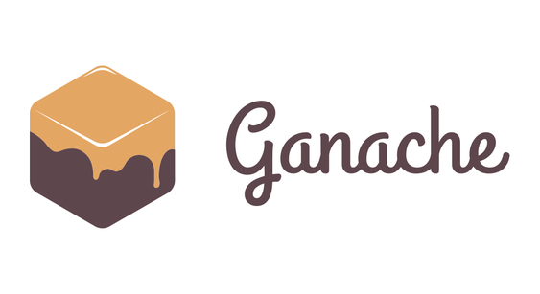

***FIG.3.6 GANACHE***

**3.5.5 JAVASCRIPT:**

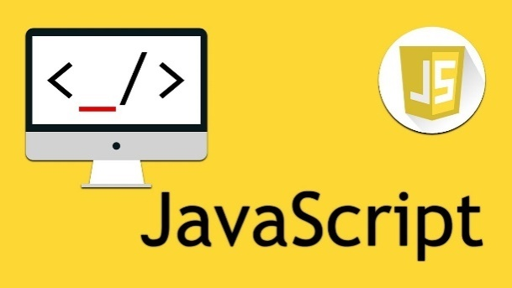JavaScript is a dynamic programming language that's used for web development, in web applications, for game development, and lots more. It allows you to implement dynamic features on web pages that cannot be done with only HTML and CSS. It is an interpreted programming language with object-oriented capabilities.

***FIG.3.7 JAVASCRIPT***

**3.5.6 METAMASK:**

Metamask is a software cryptocurrency wallet used to interact with the Ethereum blockchain. Developers achieve a connection between Metamask and their decentralized applications by using a JavaScript plugin such as Web3js or Ethers to define interactions between Metamask and Smart Contracts.

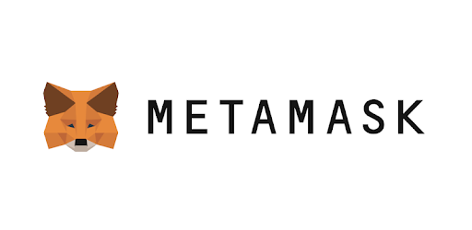

***FIG.3.8 METAMASK***

**SYSTEM DESIGN**

**4.SYSTEM DESIGN**

**4.1 E-R DIAGRAM:**

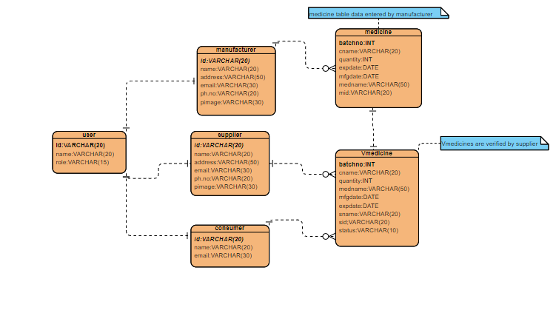

***FIG.4.1* ENTITY-RELATIONSHIP DIAGRAM**

The Manufacturer is an entity and its attributes are Id, Name, Phone number, Address and e-mail. The Medicine entity has a relationship with Manufacturer. The Medicine table data entered by the Manufacturer is recorded in the Blockchain. The Consumer is an entity with Attributes including Id, Name and email. The User and Supplier, Manufacturer, Consumer is a one-to-many relationships. The Consumer, Manufacturer, Supplier has a relationship with V-medicine and it is a one-to-many relationship, where it stores the details of the Medicine. Blockchain is a decentralized ledger that is shared by all network participants. Because of its nature, modifying an existing ledger is not mathematically possible. This is achieved through the use of cryptographic algorithms. Blockchain data structure is a list of data blocks that are timestamped, immutable, and in strict order. The manufacturer and customers being able to track pharmaceutical products throughout the supply chain, they will trust each other. V-medicine are authenticated by the Supplier which is then purchased and verified by the Consumer using QR code.

|  |  |  |
| --- | --- | --- |
| **Symbol Name** | **Symbol** | **Description** |
| Entity |  | An entity is represented by a rectangle which contains the entity’s name. |
| Attribute |  | In the Chen notation, each attribute is represented by an oval containing attribute’s name |
| Strong Relationship |  | A relationship where entity is existence-independent of other entities, and PK of Child doesn’t contain PK component of Parent Entity. A strong relationship is represented by a single rhombus |
| One or More |  | It represents One or More |
| Many - to - Many |  | It represents a one through many on both sides of a relationship |

***TABLE 4.1* E-R DIAGRAM SYMBOL DESCRIPTION**

**4.2 DFD DIAGRAM:**

**4.2.1 Level 0 DFD:**

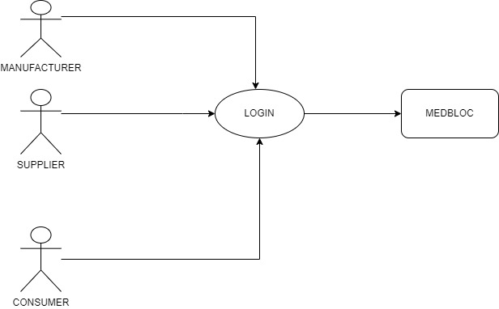

***FIG.4.2.1* LEVEL-0-DFD**

The Manufacturer login into the Medbloc application and record the medicine details. The Supplier receives the medicine and login in Medbloc application and authenticate it using the QR Code. The Consumer login Medbloc application and verify its authenticity.

**4.2.2 Level 1 DFD:**

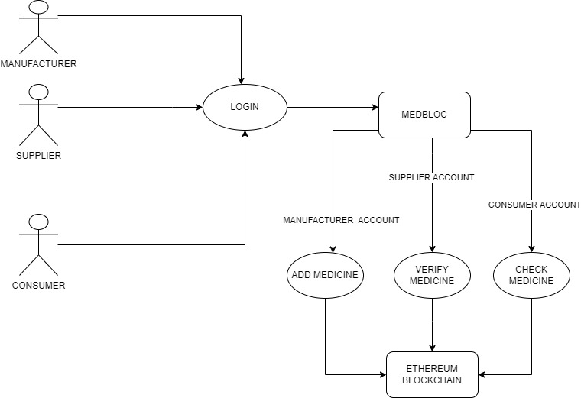

***FIG.4.2.2* LEVEL-1-DFD**

The Level 1 DFD Shows all the transactions are being recorded in the Ethereum blockchain. The Manufacturer, Supplier, Consumer all login in the Medbloc application and each account does its unique process and perform a transaction. Add Medicine adds the medicine details in the blockchain, Verify Medicine authenticate the medicine in the blockchain and store the QR code. Check Medicine fetches the details of the medicine from the Manufacturer in the Blockchain.

**4.2.3 Level 2 DFD: -**

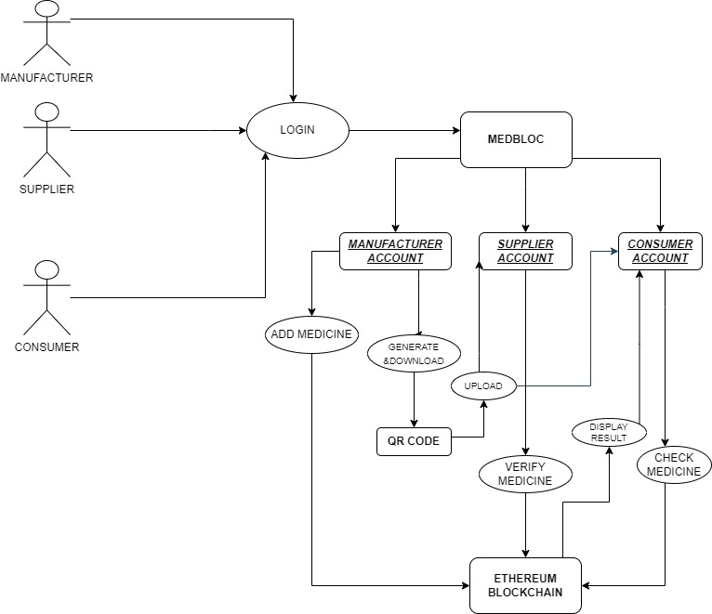

***FIG.4.2.3* LEVEL-2-DFD**

The Level 2 DFD shows the Medicine Supply Chain Management using Blockchain. The Manufacturer generates the QR Code for the medicine and uploaded it. The Supplier authenticate the QR code uploaded by the Manufacturer and authenticate the details of the medicine in the Blockchain. The Consumer purchase the Medicine from the Supplier and Scan the QR code to Check the details of Medicine from the Ethereum Blockchain. All these transactions are recorded and processed automatically into the Blockchain in the MEDBLOC application.

**4.3 UML DIAGRAM:**

**4.3.1 USE CASE DIAGRAM:**

Depicts the various users of the system and how they are going to use the system to meet the requirement objectives. Use Case Diagram for Decentralized Medicine Supply-Chain Management and Eliminate Counterfeit Medicine Using Blockchain contains Three Actors, some Use cases and Data Source.

Below are the Symbols used in Use case diagram with Description:

|  |  |  |
| --- | --- | --- |
| **Symbol Name** | **Symbol** | **Description** |
| Actor |  | Actors are the users of a system. |
| Use case |  | Label the ovals with verbs that represent the system's functions. |
| Data Source |  | A Non-Human Actor is represented by this symbol. |

***TABLE 4.3.1* USE CASE DIAGRAM SYMBOL DESCRIPTION**

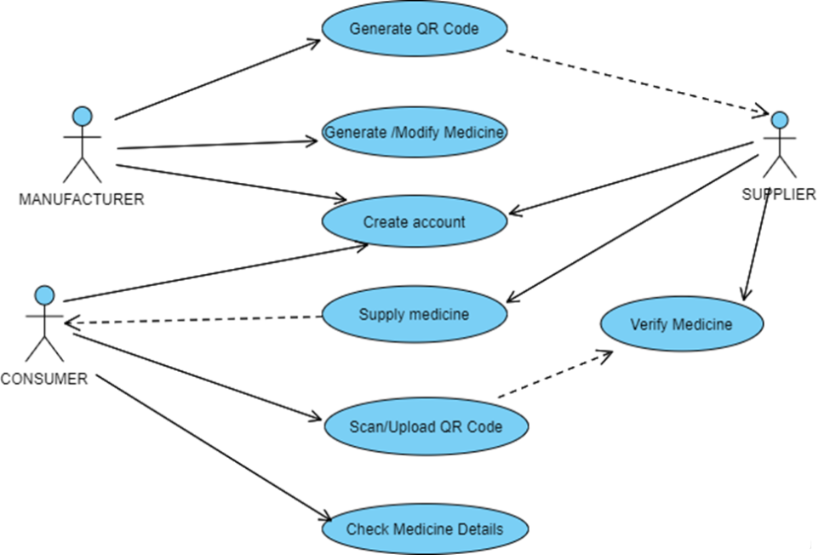

***FIG.4.3.1* USECASE DIAGRAM**

**4.3.2 ACTIVITY DIAGRAM:**

Activity diagram is another important diagram in UML to describe the dynamic aspects of the system. Activity diagram is basically a flowchart to represent the flow from one activity to another activity. The activity can be described as an operation of the system. The control flow is drawn from one operation to another.

|  |  |  |
| --- | --- | --- |
| **Symbol Name** | **Symbol** | **Description** |
| Start/Initial State |  | A small filled circle followed by an arrow represents start point for any activity diagram. |
| Activity State |  | An action state represents the non-interruptible action of objects. |
| Decisions and Branching |  | A diamond represents a decision with alternate paths. The outgoing alternates should be labelled with a condition or guard expression. You can also label one of the paths "else." |
| Final State |  | An arrow pointing to a filled circle nested inside another circle represents the final action state. |

***TABLE 4.3.2* ACTIVITY DIAGRAM SYMBOL DESCRIPTION**

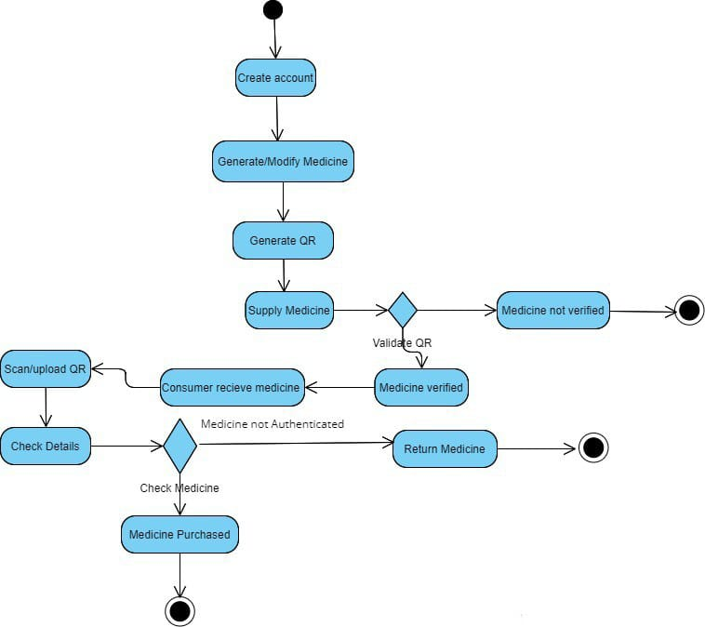

***FIG.4.3.2* ACTIVITY DIAGRAM**

**4.3.3 CLASS DIAGRAM:**

Class diagram, one of the most commonly used diagrams in object-oriented system, models the static design view for a system. The static view mainly supports the functional requirements of a system – the services the system should provide to the end users. We will see from our practical experience that lots of fun comes out when modeling out system with class diagrams. A class diagram shows a set of classes, interfaces, and collaborations and their relationships. Class diagrams involve global system description, such as the system architecture, and detail aspects such as the attributes and operations within a class as well. The most common contents of a class diagram are:

● Classes

● Interfaces

● Collaborations

● Dependency, generalization, and association relationships

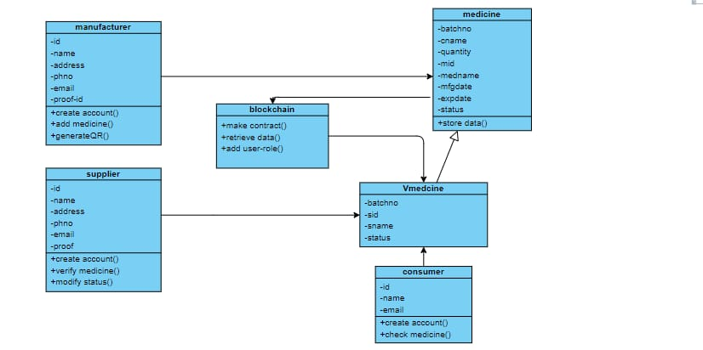● Notes and constraints

***FIG.4.3.3* CLASS DIAGRAM**

**4.3.4 COMPONENT DIAGRAM:**

Component diagrams are different in terms of nature and behavior. Component diagrams are used to model the physical aspects of a system Component diagrams are used to visualize the organization and relationships among components in a system. These diagrams are also used to make executable systems.

|  |  |  |
| --- | --- | --- |
| **Symbol Name** | **Symbols** | **Description** |
| Component |  | **It** represents a modular part of a system. A component defines its behavior in terms of provided and required interfaces. |
| Package |  | **It** is used to group elements, and to provide a namespace for the grouped elements. |
| Dependency |  | It is a relationship in which one element, the client, uses or depends on another element, the supplier. |
| **Generalization** |  | It is a relationship in which one model element (the child) is based on another model element (the parent). |

***TABLE 4.3.3* COMPONENT DIAGRAM SYMBOL DESCRIPTION**

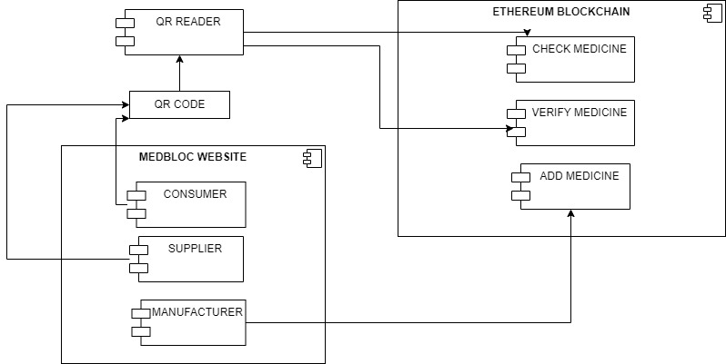

***FIG.4.3.4 COMPONENT* DIAGRAM**

**4.3.5 SEQUENCE DIAGRAM:**

Sequence diagram shows an interaction among a set of objects. The purpose of the Sequence diagram is to document the sequence of messages among objects in a time-based view. The scope of a typical sequence diagram includes all the message interactions for a single use case. There may be multiple sequence diagrams per use case, one per use case scenario. The sequence diagrams commonly contain:

● Objects

● Links

● Messages

● Respond Time (especially useful in real-time systems)

The vertical “lifelines” represents objects of interest. Messages are shown flowing between object lifelines. UML supports the notation of respond time in the sequence diagrams, which makes it feasible to specify the performance requirements for a real time system. Time flows from top to bottom.

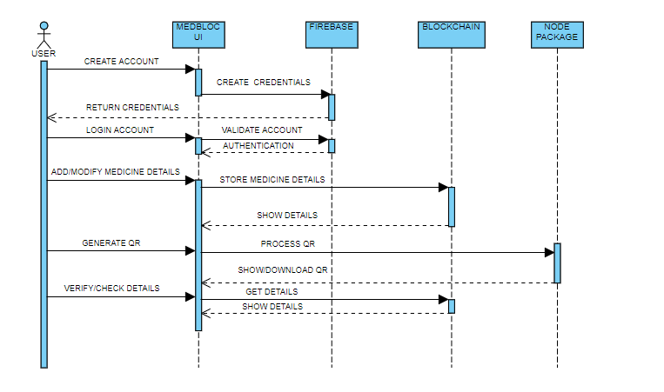

***FIG.4.3.5 SEQUENCE* DIAGRAM**

**4.3.6 DATA DICTIONARY:**

The data dictionary is an organized listing of all data elements that are pertinent to the system, with precise, rigorous definitions so that both user and system analyst will have a common understanding of inputs, outputs, components of stores and intermediate calculations.

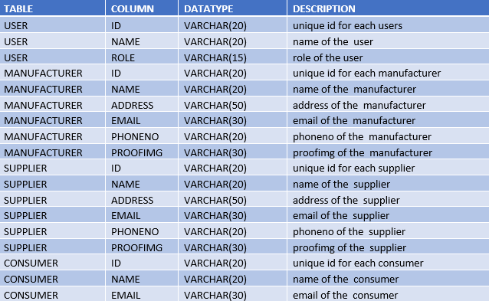

***TABLE 4.3.6 DATA DICTIONARY* DESCRIPTION**

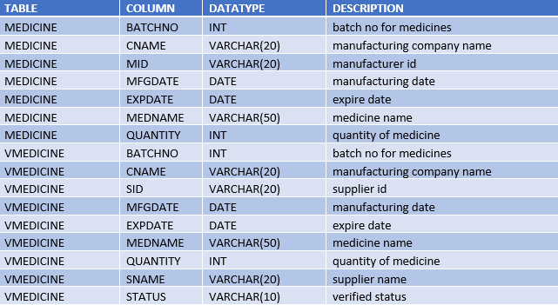

***TABLE 4.3.6 DATADICTIONARY* DESCRIPTION**

**SYSTEM ARCHITECTURE AND**

**MODEL REPRESENTATION**

**5. SYSTEM ARCHITECTURE& MODEL REPRESENTATION**

**5.1 SYSTEM ARCHITECTURE:**

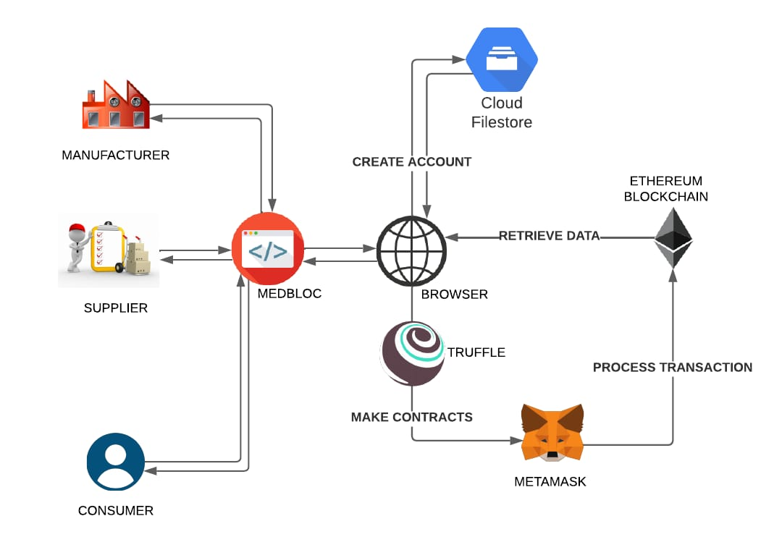

***FIG.5.1* SYSTEM ARCHITECTURE**

The purpose of MEDBLOC to incorporate the features of blockchain technology and add traceability, and security to the drugs supply chain, and to provide visibility to manufacturers and drugs regulatory authority of the SUPPLY CHAIN MANAGEMENT system. The distributed ledger technology records the immutable and transparent transactions, logs, and histories of all events and actions taken in the network. The manufacturer and customers being able to track pharmaceutical products throughout the supply chain, they will trust each other. Once the manufacturer produces a product, he will register it on the blockchain, and here after the drugs will be tracked, traced and authenticated at each stage of their journey. As the drugs ownership change physically, its ownership will be transferred simultaneously on the blockchain network. Drugs manufacturers will be able to see the journey of their products at any of time, from manufacturing to packagers, and from packagers to distributers. Blockchain is the best technology for the trade-off that can guaranty to verify the originality of a piece of data that is made available public while keeping the private data of an entity secrete and without any compromise on privacy. The supplier accesses the blockchain and authenticate the originality of the stock, then the transaction is processed in the blockchain network. QR code are created for the products which can be downloaded by the users. The consumer can purchase the medicine and verify its authenticity by scanning or upload the QR code and check the details in the blockchain network.

**5.2 MODULE DESIGN SPECIFICATION:**

**5.2.1 MODEL REPRESENTATION OF MEDBLOC:**

**Create Account:**

Account can be created by Manufacturer, Supplier, Consumer in Blockchain by giving these details like Id, Name, Address, Phone NO, Email ID, Proof ID etc.

**Add Medicine:**

We can add medicine in Blockchain by giving these details like Batch NO, Company Name, Quantity, Medicine Name, Status etc.

**Check Medicine Status:**

Medicine status can be checked by Manufacturer, Supplier, Consumer by login into user’s account.

**Generate QR Code:**

We can generate QR code through JavaScript Library. These OR code can be downloaded by Manufacturer, Supplier, Consumer.

**Authenticate User:**

User account are authenticated and store user details to the blockchain like Id, Name, Address, Phone NO, Email ID, Proof ID etc.

**5.2.2 User Details Registration:**

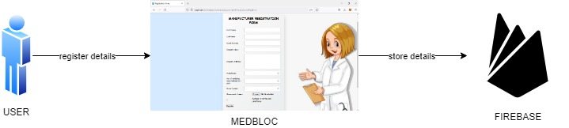

***FIG.5.2.2 User’s Detail Registration***

This module represents the User details registration process. In this module there is a sequence of steps. First step indicates, Storing the necessary details of the user. The Manufacturer, The Supplier, The Consumer give their information and complete the registration process in the Medbloc Application. The information is gathered and stored in the cloud storage.

**5.2.3 User Account Creation:**

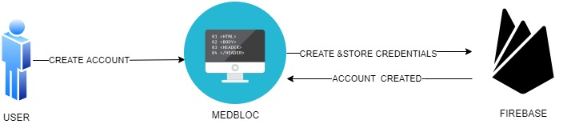

***FIG.5.2.3 User Account Creation***

This module explains how the user creates an account in the MEDBLOC Application. The user fills the login credentials the application, then the application verifies the user account details and stores in the Firebase and the User account is created, then the user can login in the application using email ID and Password.

**5.2.4 Add Medicine details:**

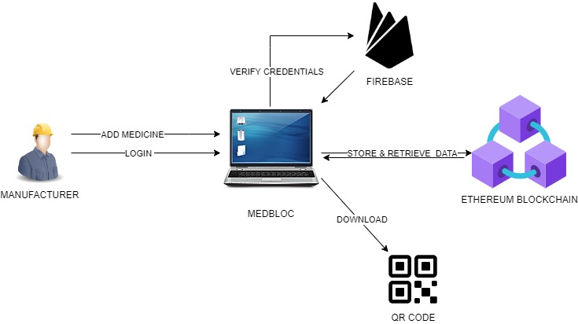

***FIG.5.2.4 Add Medicine details***

In this module we are going to add medicine details of the products created by the registered Manufacturer .The Manufacturer Login into the MEDBLOC by verifying the credentials and store the medicine details,this transaction is recorded in the Ethereum Blockchain. The manufacturer generates QR code for the medicine details stored in the blockchain.Then the manufacturer uploads the QR code to the Supplier which is further used to access the Medicine details.

**5.2.5 Verify Medicine details:**

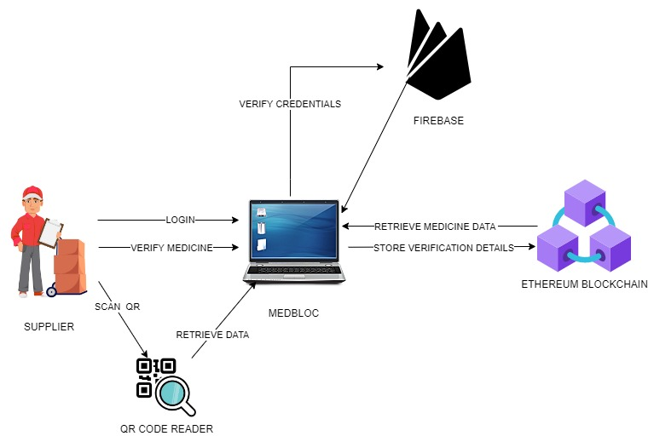

***FIG.5.2.5 Verify Medicine details***

In this Module, The Supplier logins in the application by verifying the login credentials and scans the QR code uploaded by the Manufacturer and retrieve data from the Medbloc application. The Medbloc retrieve the Medicine data from the Blockchain and stores the verification details in the Blockchain. The Supplier distribute the medicine to the Consumer after completion of the authentication process.

**5.2.6 Check Medicine details:**

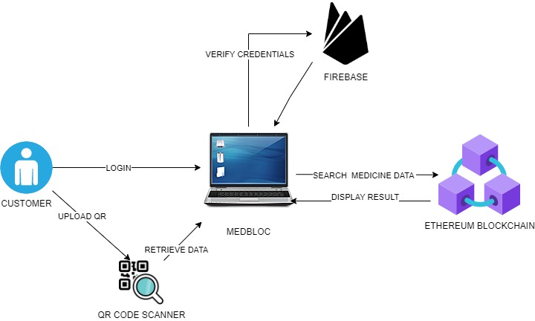

***FIG.5.2.6 Check Medicine details***

In this module, the Consumer login in the Medbloc application using the login credentials, the application verifies the consumer details in stored in Firebase. The Consumer upload the QR code of the medicine purchased from the Supplier in the application. Medbloc retrieve medicine details from the Blockchain and displays the result in the application, then the Consumer check the result whether the medicine purchased is original or counterfeit.

**SYSTEM IMPLICATIONS**

**6.SYSTEM IMPLICATIONS**

**6.1 Working Principle of Medicine Supply-Chain Management System:**



***FIG.6.1* Working of Medicine Supply chain Management System**

The above diagram describes the Working of Medicine Supply chain Management System. At first Step, Storing the necessary details of the user. The Manufacturer, The Supplier, The Consumer give their information and complete the registration process in the Medbloc Application. The information is gathered and stored in the cloud storage. Once the manufacturer produces a product, he will register it on the blockchain, and here after the drugs will be tracked, traced and authenticated at each stage of their journey. Blockchain data structure is a list of data blocks that are timestamped, immutable, and in strict order Once the manufacturer produce a product, he will register it on the blockchain, and here after the drugs will be tracked, traced and authenticated at each stage of their journey.

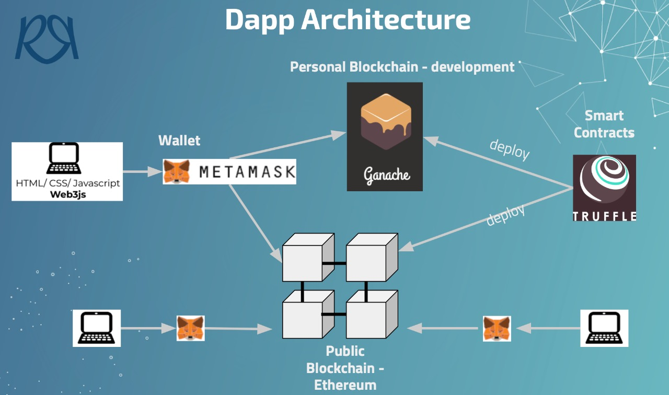As the drugs ownership change physically, its ownership will be transferred simultaneously on the blockchain network. Drugs manufacturers will be able to see the journey of their products at any of time, from manufacturing to packagers, and from packagers to distributers.

***FIG.6.2* Working of Medicine Supply chain Management System**

The user fills the login credentials the application, then the application verifies the user account details and stores in the Firebase and the User account is created, then the user can login in the application using email ID and Password. The Manufacturer Login into the MEDBLOC by verifying the credentials and store the medicine details,this transaction is recorded in the Ethereum Blockchain. The manufacturer generates QR code for the medicine details stored in the blockchain. The supplier accesses the blockchain and authenticate the originality of the stock, then the transaction is processed in the blockchain network. QR code are created for the products which can be downloaded by the users. The Medbloc retrieve the Medicine data from the Blockchain and stores the verification details in the Blockchain. The Supplier distribute the medicine to the Consumer after completion of the authentication process. The consumer can purchase the medicine and verify its authenticity by scanning or upload the QR code and check the details in the blockchain network. MEDBLOC incorporates the features of blockchain technology and add traceability, and security to the drugs supply chain, and to provide visibility to manufacturers and drugs regulatory authority of the SUPPLY CHAIN MANAGEMENT system.

**TESTING**

**7. TESTING**

**7.1 Testing Objectives**

The purpose of testing is to discover errors. Testing is the process of trying to discover every conceivable fault or weakness in a work product. It provides a way to check the functionality of components, sub-assemblies, assemblies and/or a finished product. It is the process of exercising software with the intent of ensuring that the Software system meets its requirements and user expectations and does not fail in an unacceptable manner. There are various types of tests. Each test type addresses a specific testing requirement.

**7.2 TYPES OF TESTS**

**7.2.1 Unit Testing**

Unit testing involves the design of test cases that validate that the internal program logic is functioning properly, and that program inputs produce valid outputs. All decision branches and internal code flow should be validated. It is the testing of individual software units of the application. It is done after the completion of an individual unit before integration. Unit tests perform basic tests at component level and test a specific business process, application, and/or system configuration.

**7.2.2 Integration Testing**

Integration tests are designed to test integrated software components to determine if they actually run as one program. Testing is event driven and is more concerned with the basic outcome of screens or fields. Integration tests demonstrate that although the components were individually satisfaction, as shown by successfully unit testing, the combination of components is correct and consistent.

**7.2.3 Functional Testing**

Functional testing provides systematic demonstrations that functions tested are available as specified by the business and technical requirements, system documentation, and user manuals.

Functional testing is centered on the following items:

**Valid Input:** identified classes of valid input must be accepted.

**Invalid Input:** identified classes of invalid input must be rejected.

**Functions:** identified functions must be exercised.

**Output:** identified classes of application outputs must be exercised.

**7.2.4 System Testing**

System testing ensures that the entire integrated software system meets requirements. It tests a configuration to ensure known and predictable results. An

example of system testing is the configuration-oriented system integration test. System testing is based on process descriptions and flows, emphasizing pre-driven

process links and integration points.

**7.2.5 Acceptance Testing**

User Acceptance Testing is a critical phase of any project and requires

significant participation by the end user. It also ensures that the system meets the functional requirement.

**7.3 TESTCASES AND RESULTS:**

|  |  |  |  |  |
| --- | --- | --- | --- | --- |
| **S.No** | **Test Cases** | **Expected Output** | **Actual Output** | **Status** |
| 1. | User registering in the Medbloc application by giving User registration details | It Should Display User Account Created successfully | It displays User Account Created successfully | PASS |
| 2. | User attempt to Login by giving user Credentials in the Medbloc Application | It Should fetch & display user home page with user details | It displays user home page with user details successfully | PASS |
| 3. | Add Medicine details in the manufacturer page | It should display product is created successfully | It displays the product is created successfully | PASS |
| 4. | Generate QR code for the stored medicine details | It should display the QR code generated successfully | It displays the QR code generated successfully | PASS |
| 5. | Get medicine details by reading the QR code by Consumer | It should display the medicine details of product | It displays the medicine details of product | PASS |
| 6. | Verify the medicine details of  The uploaded QR code | It should display the medicine details verified successfully | It displays the medicine details verified successfully | PASS |

***TABLE 7.3* TEST CASES AND POSSIBLE RESULTS**

**CONCLUSION AND FUTURE ENHANCEMENT**

**8. CONCLUSION**

**8.1 Conclusion:**

Thus, this project has many advantages and provides a scope of improvement in the future product supply chain field. The manufacturer and customers are able to track medical products throughout the supply chain, they will trust each other is the main objective of the project. There is also a scope extending of the present idea in Healthcare, E-commerce and other activities that needs Automated Decentralized Application management system.

**8.2 Future Enhancement:**

The Medbloc application is a single platform web application. we can create Android application for Medbloc and integrated different platform users together and improve accessibility. We can implement Medbloc for other blockchain applications. We can implement decentralized application into larger and diverse platforms. We can change to a different blockchain which offers cheaper gas price. Decentralized application can be implemented in healthcare, Banking, E-commerce and other area which required more transparency and high security.

**APPENDICES**

**APPENDICES**

**9.1 Sample Coding:**

**Login.js**

const signin=firebase.initializeApp(firebaseConfig1,'signin');

const auth = signin.auth();

const db=firebase.initializeApp(firebaseConfig,'db');

const signupForm = document.querySelector('#sign-up-form');

signupForm.addEventListener('submit',(e) => {

    e.preventDefault();

    //get user info

    const name=signupForm['signup-name'].value;

    const email = signupForm['signup-email'].value;

    const password = signupForm['signup-password'].value;

    var data = {

        name: name,

        mail:email,

        pass:password

    } ;

    //sign up the user

    auth.createUserWithEmailAndPassword(email,password)

    .then(cred => {

            window.alert("Account Created Sucessfully!!");

            const modal = document.querySelector('#sign-up');

            window.location.href="html/manufacturerReg.html";

    })

    .catch((error) => {

        var errorCode = error.code;

        var errorMessage = error.message;

        window.alert(errorMessage);

        signupForm.reset();

        console.log(errorCode,errorMessage);

    })

});

const signinForm = document.querySelector('#signin-form');

signinForm.addEventListener('submit',(e) => {

    e.preventDefault();

    //get user info

    const email = signinForm['signin-email'].value;

    const password = signinForm['signin-password'].value;

    //sign up the user

    auth.signInWithEmailAndPassword(email,password)

    .then(cred =>{

        console.log(cred.user);

        window.alert("Logged In successfully!!");

        const modal = document.querySelector('#sign-in');

        window.location.href="html/manpro.html";

    })

    .catch((error) => {

        var errorCode = error.code;

        var errorMessage = error.message;

        window.alert(errorMessage);

        signinForm.reset();

    })

});

**AccountRegistration.js**

// Initialize Firebase

const db=firebase.initializeApp(firebaseConfig,'db');

const firestore=db.firestore();

//Reference Message Collection

//Listen for form Submit

document.getElementById('manufacturerform').addEventListener('submit', submitForm);

//Submit Form

function submitForm(e){

    e.preventDefault();

//Get Values

var fname = getInputVal('fname');

var lname = getInputVal('lname');

var emailid = getInputVal('emailid');

var cname = getInputVal('cname');

var caddress = getInputVal('caddress');

var postalcode = getInputVal('postalcode');

var medno = getInputVal('medno');

var phno = getInputVal('phno');

var govlic = getInputVal('govlic');

//Save Message

saveMessage(fname, lname,emailid, cname, caddress, postalcode, medno, phno, govlic);

}

// Function to get get form values

function getInputVal(id){

    return document.getElementById(id).value;

}

// Save message to firebase

function saveMessage(fname, lname, emailid, cname, caddress, postalcode, medno, phno, govlic){

    var name=fname.toLowerCase();

    var data = {

      fname: fname ,

      lname: lname,

      emailid: emailid,

      cname: cname,

      caddress: caddress,

      postalcode: postalcode,

      medno: medno,

      phno: phno,

      govlic: govlic

    };

firestore.collection('Manufacturer').doc(name).set(data).then(()=>{

    //Alert Message

    window.alert('Account Created');

    window.location.href="manpro.html";

    // Clear form

    document.getElementById('manufacturerform').reset();

}).catch((error)=>{

     var errorCode = error.code;

     var errorMessage = error.message;

     console.log(errorCode,errorMessage);

 });

  }

**AddMedicineBlockchain.js**

//usage:

const request='../../../build/contracts/main.json';

let contractAddress;

let contractAbi;

async function jsonf(){

  let configuration;

  const res=await fetch(request);

  const json=await res.json();

  configuration= json;

  contractAddress = configuration.networks['5777'].address; // Add Your Contract address here!!!

  // Set the Contract

  contractAbi =configuration.abi;

}

  //Listen for form Submit

  document.getElementById('medicineform').addEventListener('submit', submitForm);

  //Submit Form

  function submitForm(e) {

      e.preventDefault();

      //Get Values

      var cname = getInputVal('cname');

      var medname = getInputVal('medname');

      var dosage = getInputVal('dosage');

      var bno = getInputVal('bno');

      var mfdate = getInputVal('mfdate');

      var exdate= getInputVal('exdate');

      //Save Message

      saveMessage(cname,medname,dosage,bno,mfdate,exdate);

  }

  // Function to get get form values

  function getInputVal(id) {

      return document.getElementById(id).value;

  }

  // Save message to firebase

  function saveMessage(cname,medname,dosage,bno,mfdate,exdate) {

    var name1=localStorage['name'];

     var data={

         cname:cname,

         medname:medname,

         dosage:dosage,

         bno:bno,

         mfdate:mfdate,

         exdate:exdate,

        'status':'Not Verified',

        'mname':name1,

      };

      jsonf().then(()=>{

      const web3=new Web3( "HTTP://127.0.0.1:7545");

      web3.eth.getAccounts().then(function(accounts){

       var contract = new web3.eth.Contract(contractAbi, contractAddress);

         var medicineState = 0

            var account = accounts[0];

            console.log('Account: ' + account);

            web3.eth.defaultAccount = account;

            contract.methods.makeMedicine(bno, medname, dosage, accounts[1], accounts[0],cname, mfdate, exdate,  medicineState).send({

                from: account,

                gas: '1000000'

            });

        });

      });

      window.alert('Medicine Added !');

     window.location.href="../html/manpro.html";

      // Clear form

      document.getElementById('medicinedetails').reset();

  }

**VerifyMedicine.js**

const request='../../../build/contracts/main.json';

let contractAddress;

let contractAbi;

async function jsonf(){

  let configuration;

  const res=await fetch(request);

  const json=await res.json();

  configuration= json;

  contractAddress = configuration.networks['5777'].address; // Add Your Contract address here!!!

  // Set the Contract

  contractAbi =configuration.abi;

}

function verifys(){

    jsonf().then(()=>{

        const web3=new Web3( "HTTP://127.0.0.1:7545");

        web3.eth.getAccounts().then(function(accounts){

         var contract = new web3.eth.Contract(contractAbi, contractAddress);

            medicineState = 1

              var account = accounts[0];

              console.log('Account: ' + account);

              web3.eth.defaultAccount = account;

        console.log(med);

        med['sname']=name1;

        med['status']='Verified';

        console.log(med);

    contract.methods.fetchMedicineBufferOne(bno).call(function(err, result) {

        console.log(err, result)

        if((err!=null)||(result[0] == "")) {

           alert('Invalid QR NOT FOUND Contact manufacturer '+mname1);

        } else {

            contract.methods.packMedicine(bno, result.medicineName, result.dosage, result.originManufacturerID, result.ownerID, result.FactoryName, result.mfgdate, result.expdate, 1,accounts[2]).send({

                from: account,

                gas: '1000000'

            });

        }

    });

    });

}

**CheckMedicine.js**

const request='../../../build/contracts/main.json';

let contractAddress;

let contractAbi;

async function jsonf(){

  let configuration;

  const res=await fetch(request);

  const json=await res.json();

  configuration= json;

  contractAddress = configuration.networks['5777'].address; // Add Your Contract address here!!!

  // Set the Contract

  contractAbi =configuration.abi;

}

function val() {

var item = document.getElementById("content").innerText;

if(item===""){

  alert("Please upload QR code once again!!!!");

}

else{

document.getElementById("scan").value = item;

const no=document.getElementById('content').innerText;

jsonf().then(()=>{

  const web3=new Web3( "HTTP://127.0.0.1:7545");

  web3.eth.getAccounts().then(function(accounts){

   var contract = new web3.eth.Contract(contractAbi, contractAddress);

        var account = accounts[0];

        console.log('Account: ' + account);

        web3.eth.defaultAccount = account;

        contract.methods.fetchMedicineBufferTwo(no).call(function(err, result) {

          console.log(err, result)

          if (result[0] == "") {

          alert("QR NOT FOUND please check the medicine");}

            else{

            contract.methods.receiveMedicine(no).send({from:account,gas: '1000000'});

            contract.methods.fetchMedicineBufferThree(no).call(function(err, result) {

             console.log(err, result)

             if (result[0] == "") {

           console.log('QR NOT FOUND');

             } else {

               console.log('QR:'+result);

             }

           });

            }

        });

    });

});

}

}

**9.2 Screen Shots:**

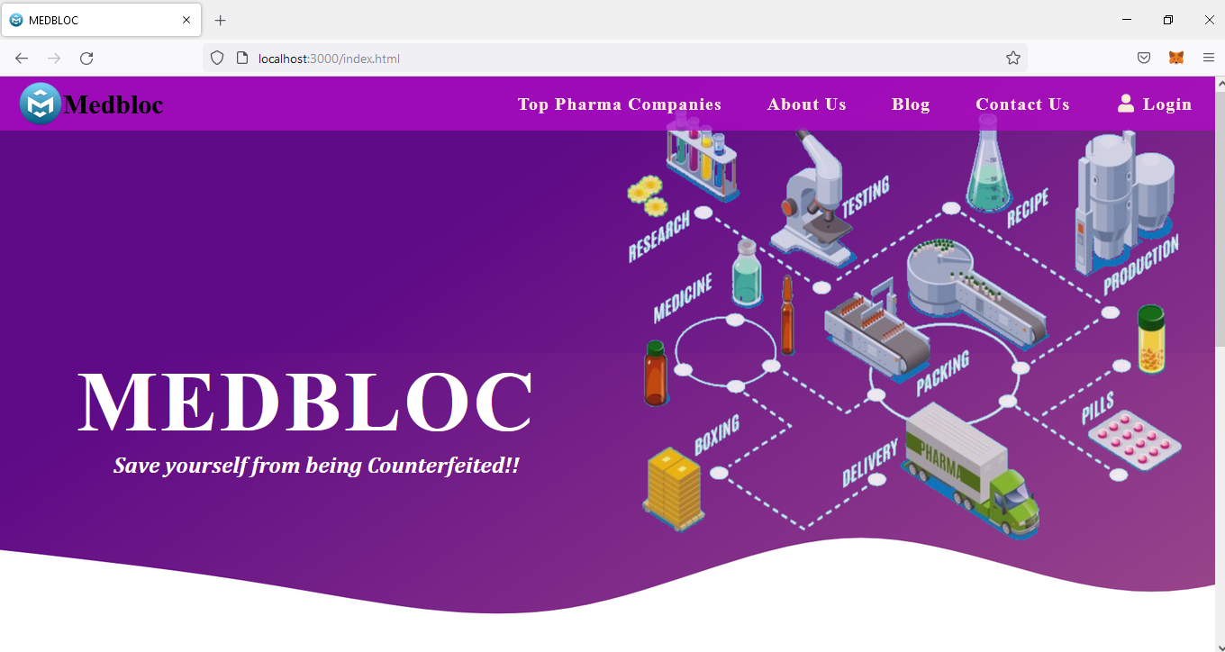

***FIG.A.1* Screenshot OF welcome page (MEDBLOC)**

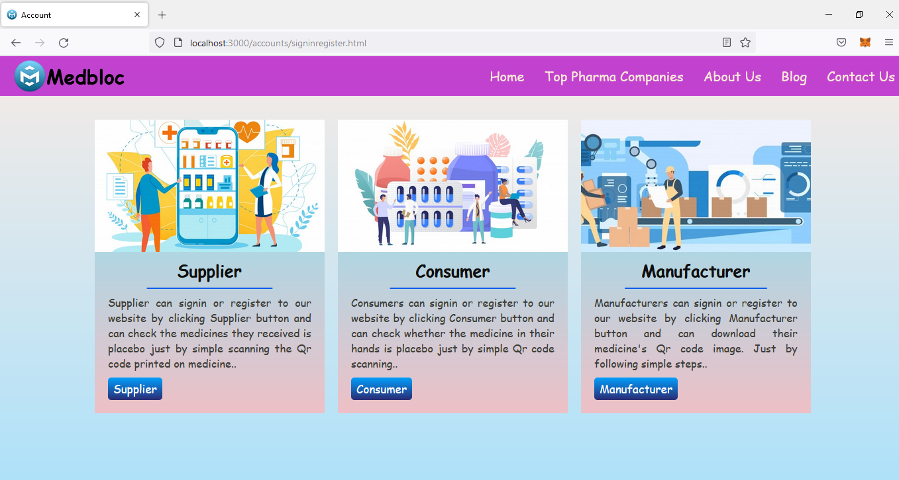

***FIG.A.2* Screenshot of user selection page**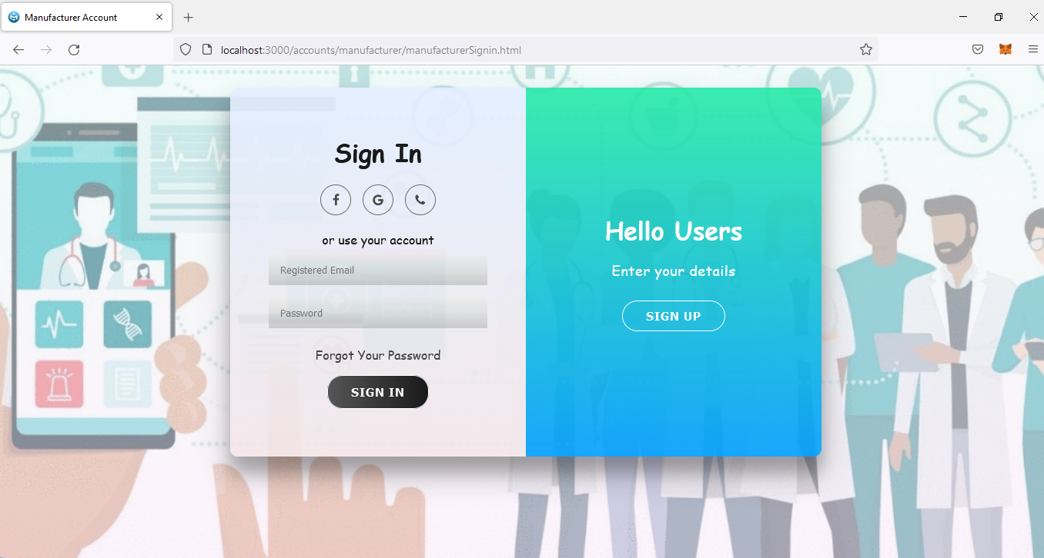

***FIG.A.3*Screenshot of account login page**

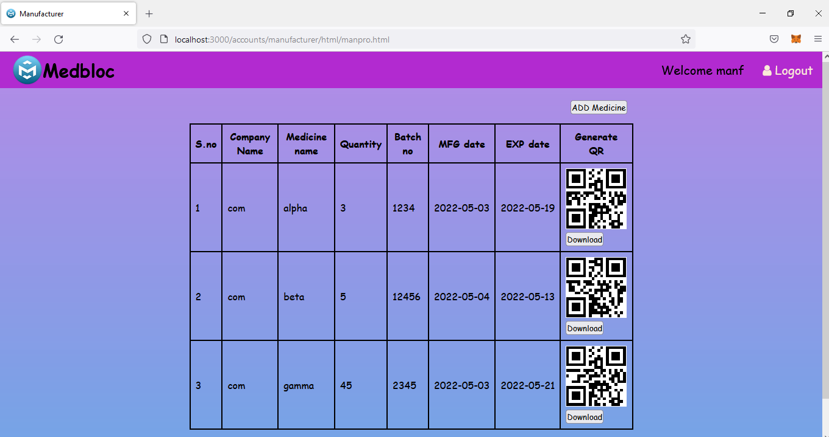

***FIG.A.4* Screenshot of manufacturer entered medicine details in blockchain**

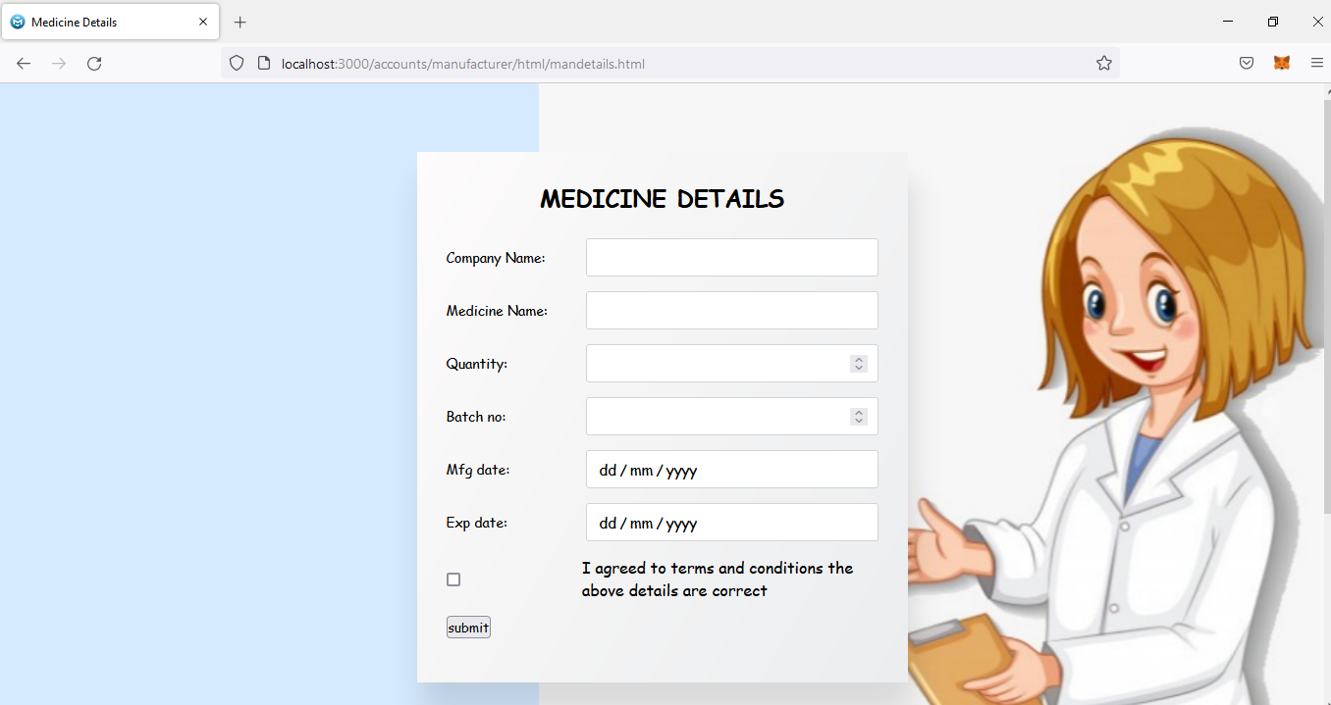

***FIG.A.5* Screenshot of entering medicine details page**

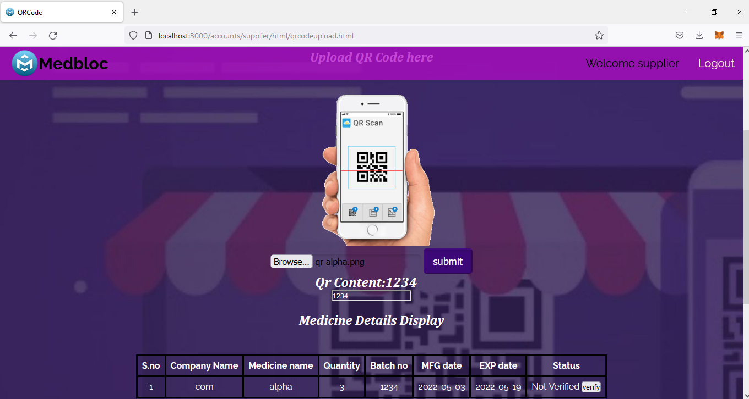

***FIG.A.6* Screenshot of supplier page before verify medicine**

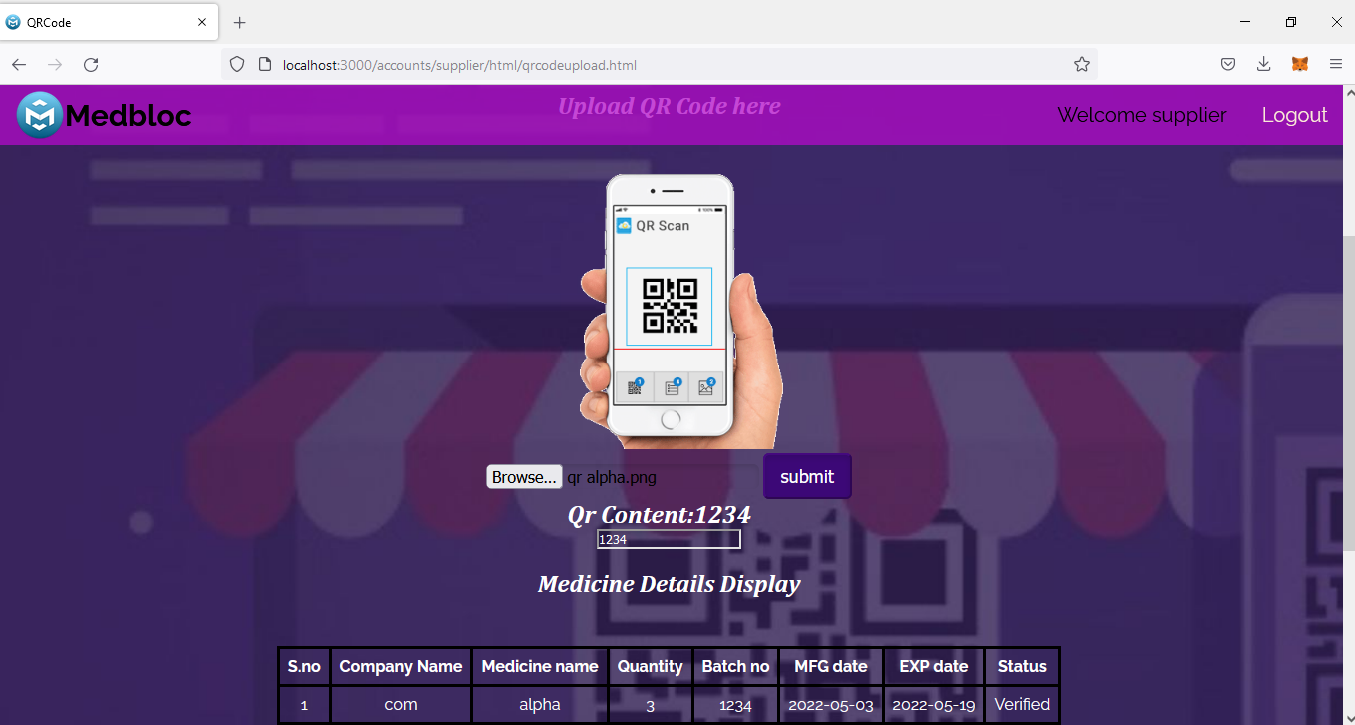

***FIG.A.7* Screenshot of supplier page after verification**

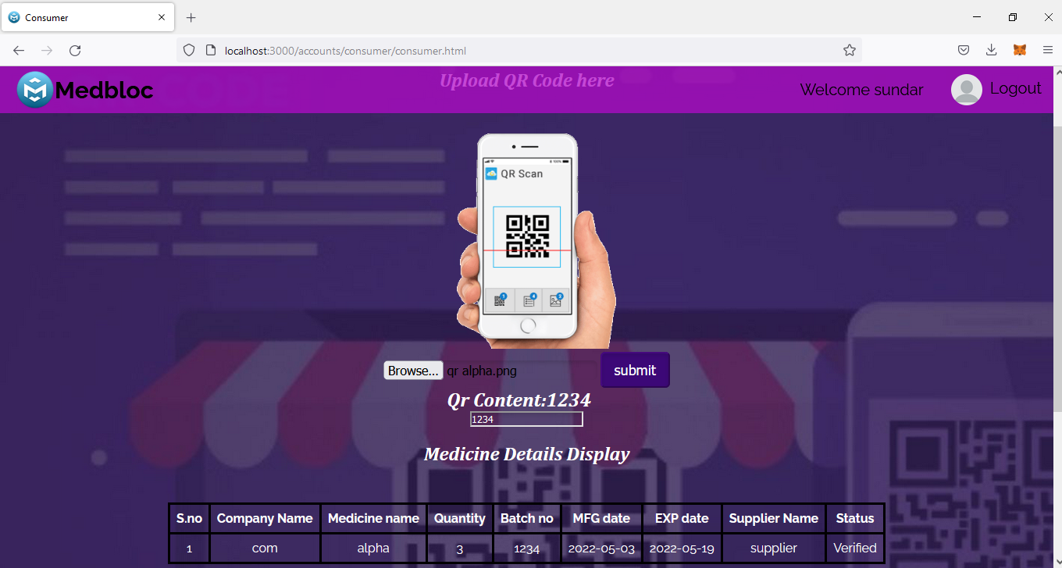

***FIG.A.8* Screenshot of consumer page to check a medicine**

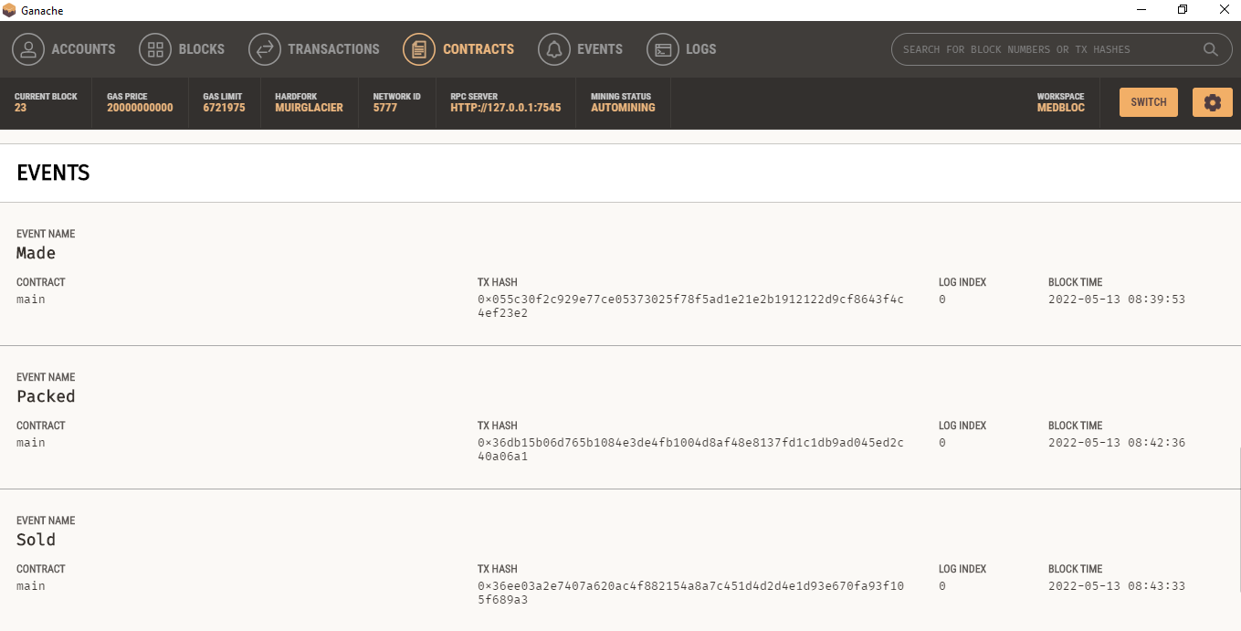

***FIG.A.9* Screenshot of medicine details entered in blockchain**

**BIBILIOGRAPHY**

**10. BIBILIOGRAPHY**

[1] U. Padmavathi and N. Rajagopalan, ‘‘Concept of blockchain technology and its emergence,’’ in Blockchain Applications in IoT Security. Hershey, PA, USA: IGI Global, 2021.

[2]Ekblaw, A.; Azaria, A.; Halamka, J.D.; Lippman, A. A Case Study for Blockchain in Healthcare: “MedRec” prototype for electronic health records and medical research data. In Proceedings of the IEEE Open & Big Data Conference, Vienna, Austria, 22–24 August 2016.

[3]. Francisco K and Swanson D. The supply chain has no clothes: technology adoption of blockchain for supply chain transparency. Logistics 2018;

[4].Lemieux, V.L. Trusting records: Is Blockchain technology the answer? Rec. Manag. J. 2016

[5].Kumar, T.; Ramani, V.; Ahmad, I.; Braeken, A.; Harjula, E.; Ylianttila, M. Blockchain Utilization in Healthcare: Key Requirements and Challenges. In Proceedings of the 2018

[6].Medicalchain, Medicalchain Whitepaper 2.1. Tech. Rep. Medicalchain, 2018. Available online: https://medicalchain.com/Medicalchain-Whitepaper-EN.pdf (accessed on 14 March 2019).

[7].Schlegel, M.; Zavolokina, L.; Schwabe, G. Blockchain Technologies from the Consumers’ Perspective: What Is There and Why Should Who Care? In Proceedings of the 51st Hawaii International Conference on System Sciences, Hilton Waikoloa Village, HI, USA, 3–6 January 2018.

[8] Zhang, P.; Walker, M.A.; White, J.; Schmidt, D.C.; Lenz, G.Metrics for assessing blockchain-based healthcare decentralized apps. In Proceedings of the 2017 IEEE 19th International Conference on e-Health Networking, Applications and Services (Healthcom), Dalian, China, 12–15 October 2017.

[9] Yue, X.; Wang, H.; Jin, D.; Li, M.; Jiang, W. Healthcare data gateways: Found healthcare intelligence on blockchain with novel privacy risk control. J. Med. Syst. 2016, 40

[10] Witchey, N.J. Healthcare Transaction Validation via Blockchain, Systems and Methods. U.S. Patent No. 10,340,038, 2 July 2019.

[11] Rabah, K.V.O. Challenges & opportunities for blockchain powered healthcare systems: A review. Mara Res. J. Med. Health Sci. 2017,

[12] Hölbl, M.; Kompara, M.; Kamisalic, A.; Zlatolas, L.N. A systematic review of the use of blockchain in healthcare. Symmetry 2018,

[13] McGhin, T.; Choo, K.-K.R.; Liu, C.Z.; He, D. Blockchain in healthcare applications: Research challenges and opportunities. J. Netw. Comput. Appl. 2019,

[14] Esposito, C.; De Santis, A.; Tortora, G.; Chang, H.; Choo, K.K.R. Blockchain: A panacea for healthcare cloud-based data security and privacy? IEEE Cloud Computing. 2018.